**VENUE BOOKING SYSTEM**

**Project Abstract**

**Version 1.0**

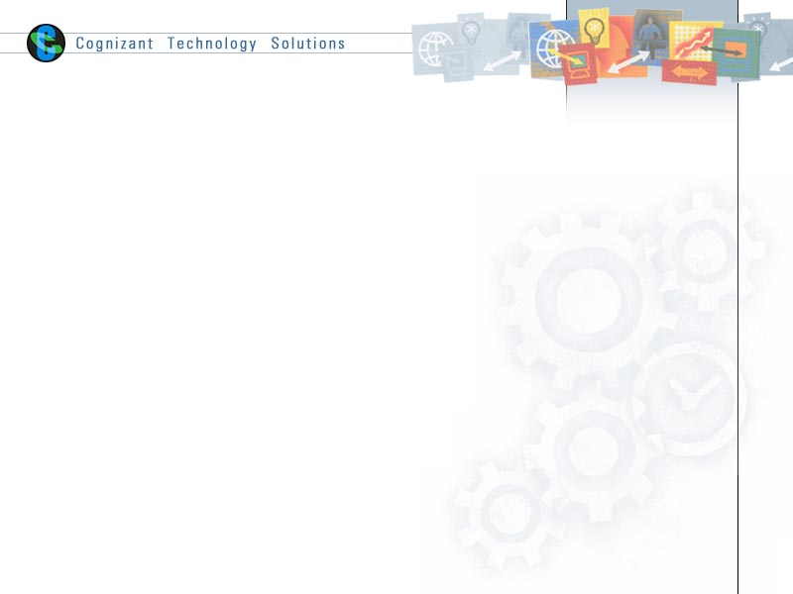

|  |  |  |  |
| --- | --- | --- | --- |
|  | Prepared By / Last Updated By | Reviewed by | Approved By |
| Name | S SHAMINI | SAINATH | <Trainer/Project Governance Representative/Cohort Mentor to fill> |
| Role | TEAM LEAD |  |  |
| Signature |  |  |  |
| Date |  |  |  |

Table of Contents

1.0 Purpose of this document 4

2.0 Business Case 4

3.0 Appendices 4

3.1 Glossary 4

3.2 Other 4

4.0 Terms & Conditions 5

5.0 Change Log 5

# Purpose of this document

This document provides an overview about the business need and the solution that can be provided to fulfil the objective.

# Business Case

The main aim of this proposal is to develop an online venue booking system which can reduce the manual work. Venue booking system is a web application in which dealers can register their venues and customers can book venues for events as per their location, availability and interest. It gives you the advantage of booking a venue at the ease of your home, which saves the person's time and energy. The customer can get the best deals on the venue booking website. Also, customers can check with the prior dates to check the availability of the venue.

# Appendices

## Glossary

|  |  |
| --- | --- |
| **Acronyms** | **Definitions** |
|  |  |

## Other

# Terms & Conditions

***Disclaimer: Please do not circulate or distribute this document outside of Cognizant Network, We have a Zero Tolerance Policy. Kindly adhere to 100% Compliance at all times.***

# Change Log

*Please note that this table needs to be maintained even if a Configuration Management tool is used.*

|  |  |  |  |  |
| --- | --- | --- | --- | --- |
| Version Number | Changes made | | | |
| V<n.n> | *<If the change details are not explicitly documented in the table below, reference should be provided here>* | | | |
| Page no | Changed by | Effective date | Changes effected |
|  |  |  |  |
|  |  |  |  |
|  |  |  |  |
|  |  |  |  |